Course: ME 302

Unique Number: 17265

Graphics Professor: Dhananjay Gupta

Semester: Fall 2019

https://lh3.googleusercontent.com/pQ5T7v3xV5Xq8rEHZ_i_8QrKq3falnDy3Xk8fCOHZyhwj_sV-xbyzxLyULnjwUWoK1jCeWC-7qLSdyjBcdzIkP7XLucAnQ_o1m8-9YezFeSaV1UA-2vvWeGj6ZfNV1frhbYgnJIj



*Oasis Engineering Group*

Talal Al Otaibi

(E-mail address: [alotaibi-talal@hotmail.com](mailto:alotaibi-talal@hotmail.com))

**Introduction:** The successful facilitation and undertaking of an engineering project is an effort that involves a strong understanding of the resources available. Moreover, completing an engineering feat involves the presence of a skillset that enables one to achieve productive efficiency at a work setting. Therefore, it is imperative that a student develops the necessary experience and skills as soon as possible to prepare himself/herself for intensive projects. In the field of mechanical engineering specifically, the design of systems necessitates a meticulous approach to its manufacturing, meaning that an engineer must plan ahead to incorporate design elements that simplify the building process and keep it a realistic and feasible level. It is here where the “Domino Challenge” shows its value: a challenge, like many, where a problem is presented and a solution is obtained. Note that this task mandates the presence of teamwork and collaboration, however the number of people in the original large group is not divisible by 2, thereby causing the author to work alone. The “Domino” Challenge instructs the design and construction of two-interlocking via the use of a 3D printer. By completing this challenge, a student’s understanding of both design itself and the process of 3D printing is enhanced: two skills which are vital in mechanical engineering and applicable in many fields such as the rapid prototyping of 3D models, manufacturing techniques, as well as the ability to adhere to required specifications. If a collaborative approach was adopted in the challenge, then project management (time and labor) and teamwork efficiency are additional learning points.

Discussion:

Without the presence of a teammate, the only alternative was to brainstorm my own ideas and proceed to evaluate them based on their strengths and weaknesses. The objective is to formulate a unique design that would prove to be challenging to design and build while simultaneously being realistic; such a challenge should be educational at its core and not unnecessarily time-consuming or too complex. Moreover, the challenge includes some restrictions which would serve as the specifications to be implemented into the chosen design (shown below).

1. Two parts
2. Each part must have a base not exceeding 0.375 inches in height, not more than 2 inches in width and depth.
3. The presence of a minimum of three pegs/ extrusions alongside matching extrusion cuts/ cavities/ holes to ensure a smooth fit.

Adhering to these requirements were the basis of design formulation and selection. Additional decisions also include the use of PLA plastic as opposed to ABS. ABS is a plastic known for having strength, ductility, and heat resistance as its primary properties, yet is prone to warping due to higher melting temperature [2]. Warping is defined as the printed surface lifting and detaching from the print plate upon shrinkage when cooling occurs [1]. Furthermore, it is suitable to rely on only 3 pegs and 3 cavities to simplify the design, maintain its compactness, and reduce design and manufacturing time. Also, the pegs and cavities are to be cylindrical in shape, as straight edged pegs are prone to high amounts of friction, causing overly tight fits, abrasions, and hence deformities to occur, even with tolerance. Cylindrical based extrusions and extrusion cuts would help mitigate this problem.

3 ideas were brainstormed and examined as indicated by figures 1 and 2 in the appendices.

The first and third ideas were eliminated, meaning that the second idea is selected.

The first idea, while ambitious, is easily the weakest. It consists of 2 hemispheres, 1 with 3 cavities and another with 3 pegs that would insert into one another, forming a full sphere. While aesthetically pleasing, compact due to the radius being no greater than 0.1875 inches, and easy to design, it fails because the workshop printers cannot create perfect spheres, resulting in some deformities and jagged edges. Therefore, many iterations would be required to create a product that is identical to the design, making this design far too costly in terms of time and materials.

The third idea is a T-shaped system constating of two thinner T-shaped pieces, one with cavities and the other with extrusions. This design’s strength comes from its simplicity of design. It is also quite easy to manufacture, is quite ergonomic and easy to grip, and is robust (especially if placed horizontally on a surface, as the weight is parallel to the peg direction. While possessing many desirable qualities, this design presents a limited amount of challenge, living little to be learnt in terms of design techniques.

The second idea, which included 2 rectangular base pyramids which interlocked to create a square base pyramid. The system is characterized by its unique aesthetic, compactness due to low height (interlocking parts did not vertically stack), and the square base provides the system with stability, The main reason behind the design selection is its challenging nature, considering the author’s lack of experience in designing a pyramid on Solidworks. An attempt to design such a system can strengthens one understanding of CAD design.

However, the design has its cons. Firstly, while the horizontal interlocking mechanism can ensure a smooth fit, the thin pegs are susceptible to fragility and can break under severe stress. This means that a non-horizontal force exerted to separate the pieces can break the pegs, making the presence of a smooth fit via tolerance even more important. Also, printing on the edge of a face may leave some jagged edges, meaning that a raft is required to print a flat base with a smooth edge. Finally, the pegs must be printed with supports attached otherwise, they may tilt or fall off: a problem exacerbated by the fact that the removal of these supports may leave some jagged edges around the cylindrical pegs if left unfiled. Therefore, additional care must be taken when handling the system post-print.

Selecting the design certainly was time consuming process, as there was no other member to discuss ideas and evaluate ideas. This meant that a more meticulous and careful approach had to be adopted to select an idea and design it. Initially, it would be tempting for one to select the easier design, and on a pragmatic level, it would be advisable. This meant that design idea 3 would practically be the safest and most rational selection. Regardless, it is of significant importance that the problem-solving skill is developed, and the educational value of a project is maximized.

The appendices outline the design process adopted.

It took two iterations to create two structurally intact pieces which matched the design. The first consisted of a support placed on the pyramid with the pegs facing upwards to eliminate the need for supports on the pegs, however the support was unstable, and eventually snapped at the end, causing the piece to fall, hence damaging the edge. The second iteration is where the raft alongside peg supports were added. To prevent the cavity holes from being covered, the pyramid piece was positioned in a manner, where the side with the holes was the base, preventing the holes from being covered in the 3D printing process.

Note that the cavity diameter is of 0.13 inches, 0.03 inches of tolerance (peg diameter is 0.10 inches). The following dimensions were also used:

* 0.35 inches in height
* 1.5 inches in width and depth
* The presence of 3 pegs and 3 matching cavities
* The cavity and peg lengths were at 0.261 inches (to maximizing locking grip), any value higher would poke the surface.

It is best if the dimensions were slightly under the maximum limits, so as to reduce the printing time and quantity of plastic used. Moreover, the maximum height, width, and depth were avoided to prevent the possibility of creating a finished product that exceeded the restricted provided dimensions.

Assessment: Upon removing the raft and peg supports, an attempt was made to fit the two pieces together. The attempt was successful, however the fit was tight, and separating the pieces required caution. The tolerance alone was not enough to ensure a smooth fit. The friction between the surfaces was too high to ergonomically handle. Further inspection shows that there were some bumps and surface irregularities. If this issue is encountered in the future, then some sand paper or a small file (swiss army knife file) can eliminate the issue. Little difficulty was faced putting pieces together, however removing them involves the exertion of a purely horizontal force, which is easier said then done. For future references, additional tolerance (preferably 40% of the original diameter) would ensure a smoother fit. The print quality was set to medium to speed up printing time, so the selection of high quality may reduce the jaggedness around the edges. Continuous and repeated insertions and removals became easier with each successive attempt, as the pegs’ surfaces alongside the cavities’ innards were smoothened out with continuous abrasions, dislodging some unwanted PLA in the process. However, this tactic should not be relied on extensively, as abrasion based, surface removal is not guaranteed for all materials (also the possibility for materials being stuck). As a contingency, lubricant would have been used to separate the pieces.

Overall, the dimensions of the finished product matched the design, and the objective of two-interlocking pieces has been met. The task of designing a pyramid and constructing involved a great deal of focus, yet would leave one at a more advantageous position due to the learning points. As a final concluding remark, working alone has furthered my understanding of the necessity of teamwork, as the task could have been completed at a much faster rate, a much smoother pace, and most importantly, a higher standard of work. Knowing this incentivizes one to recognize the importance that teamwork presents, especially in a professional setting such as a mechanical engineering project.

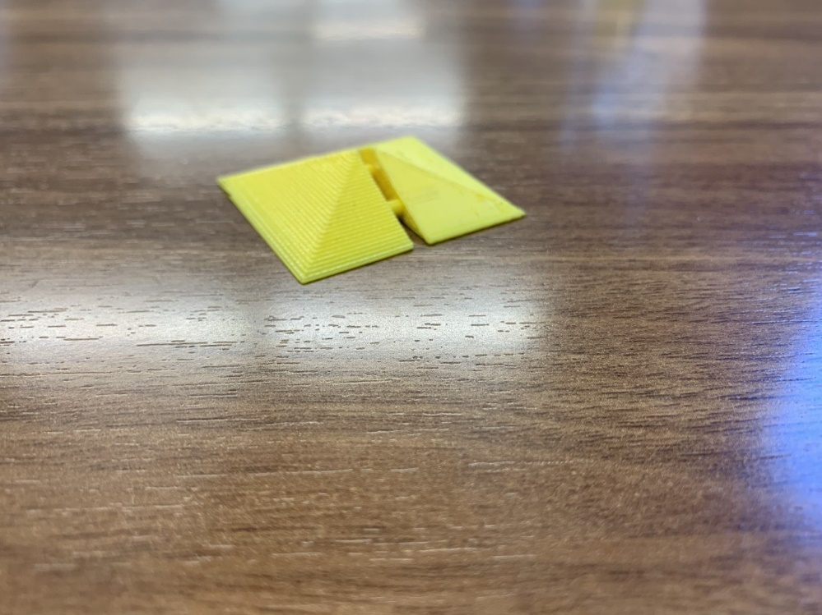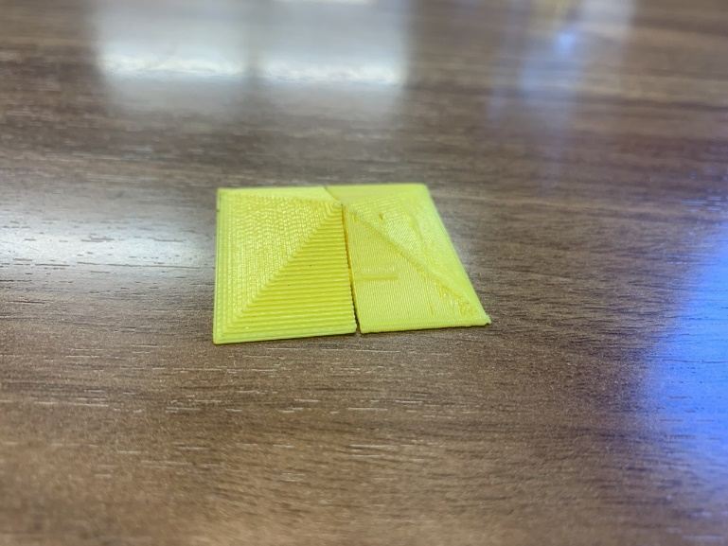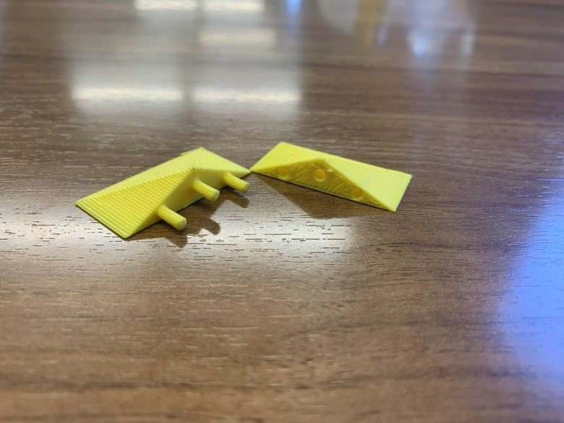Finished Product photos:

Assembled

Unassembled

Appendix:

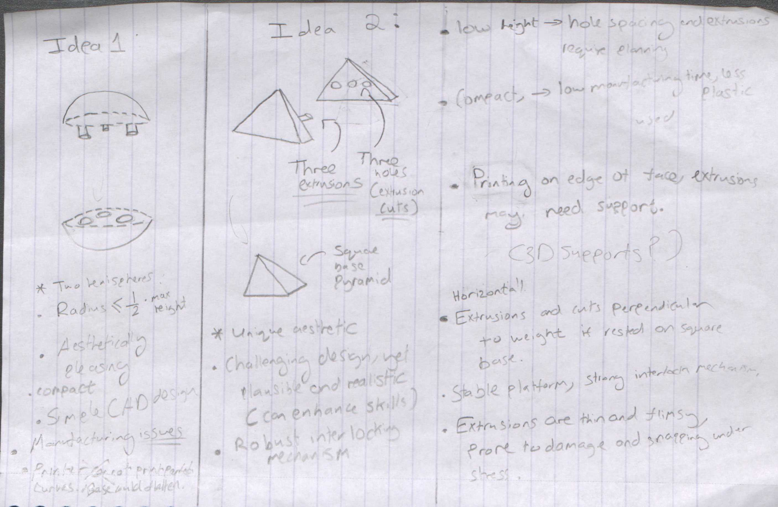

Figure : Initial design ideas 1 & 2, sketched

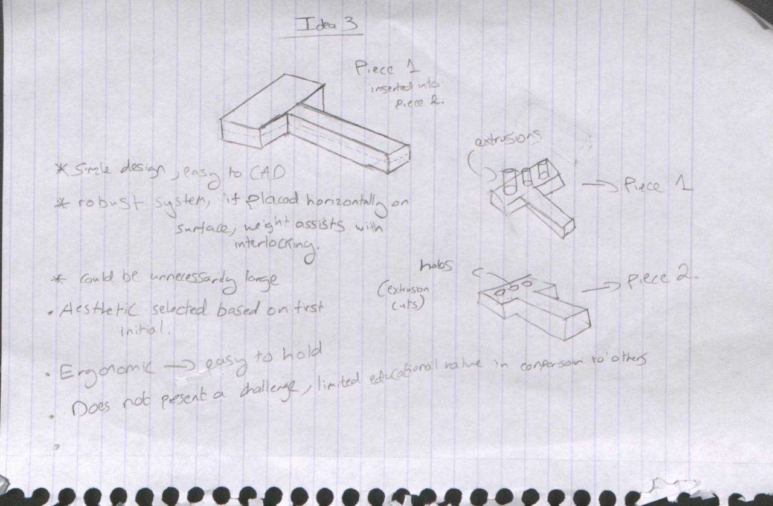

Figure : Initial Design Idea 3, sketched

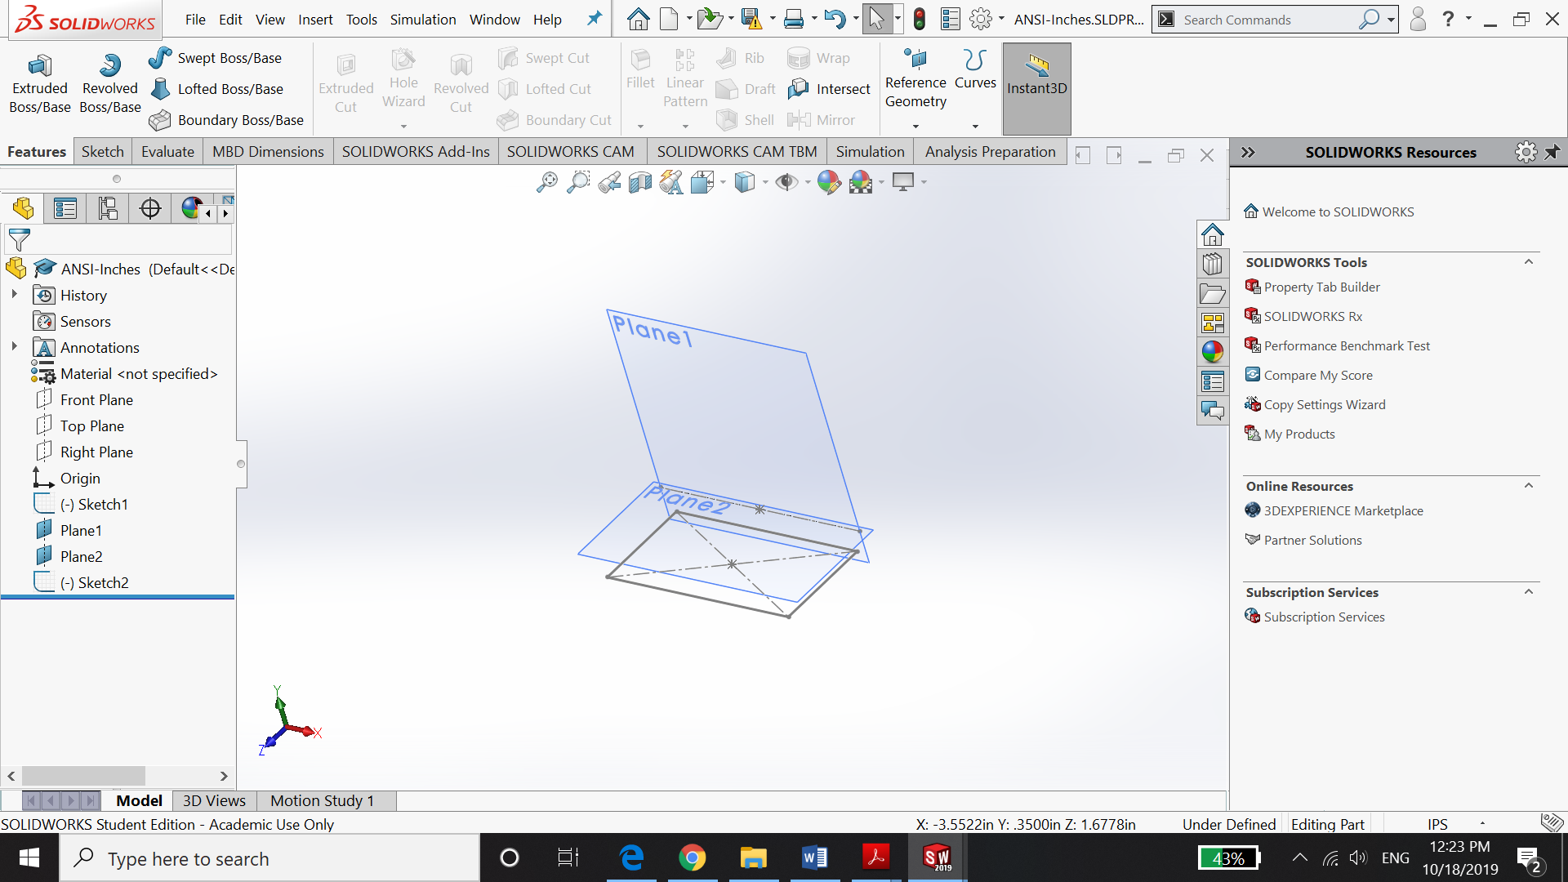

Figure : Solidworks Rectangle base with additional reference geometry planes- Pyramid Design

Note that the plane 1 and 2 are used to find the tip of the pyramid, a crucial step before lofting.

ANSI Inches file used

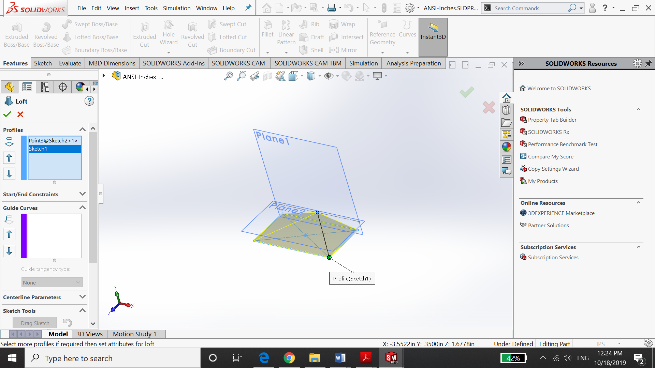

Figure : Lofted Pyramid Outline on Solidworks

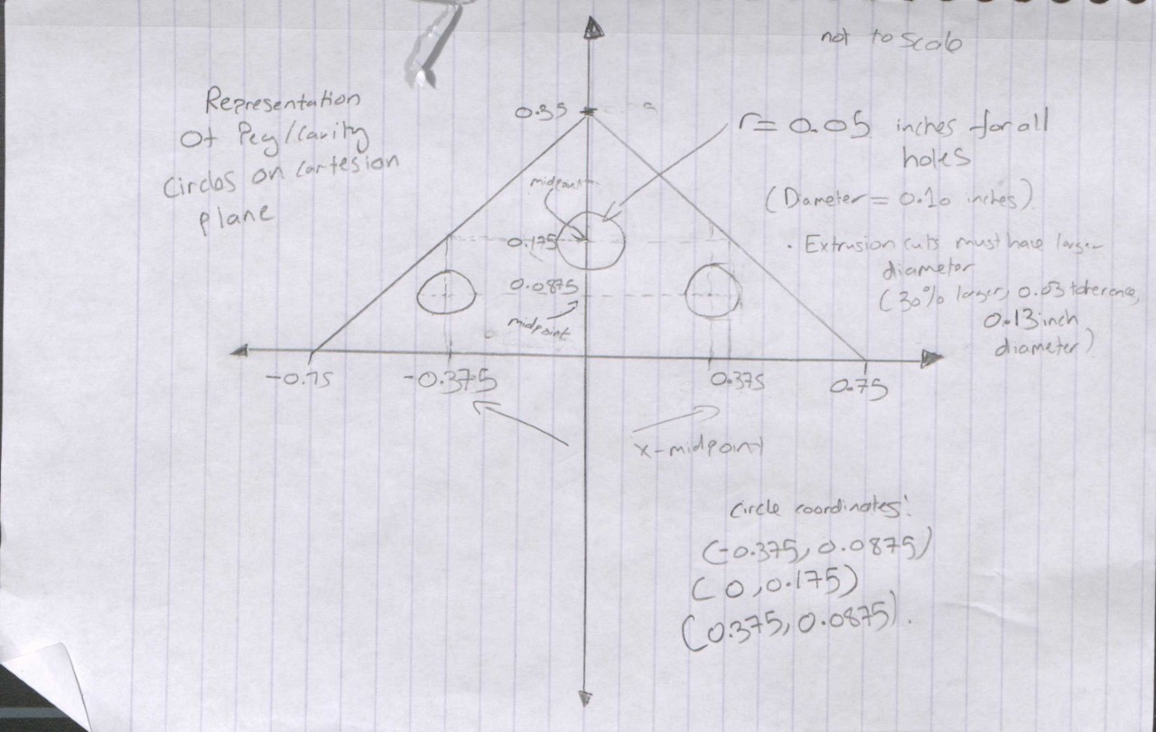

Figure : Cartesian plane showing the 3 circle outlines & coordinates-sketched.

Midpoint formula extensively used, no tolerance accounted for here.

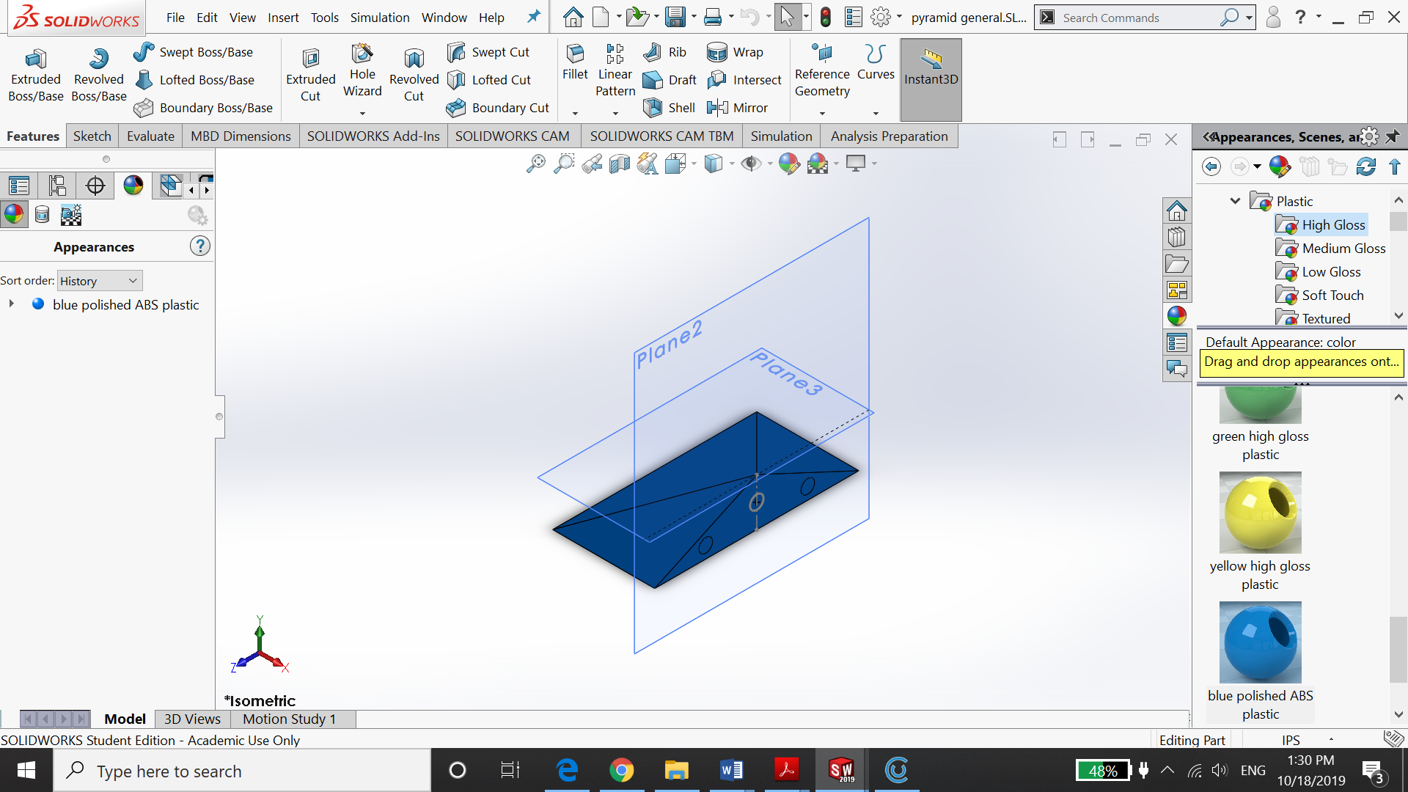

Figure : General Pyramid outline on Solidworks, with circles.

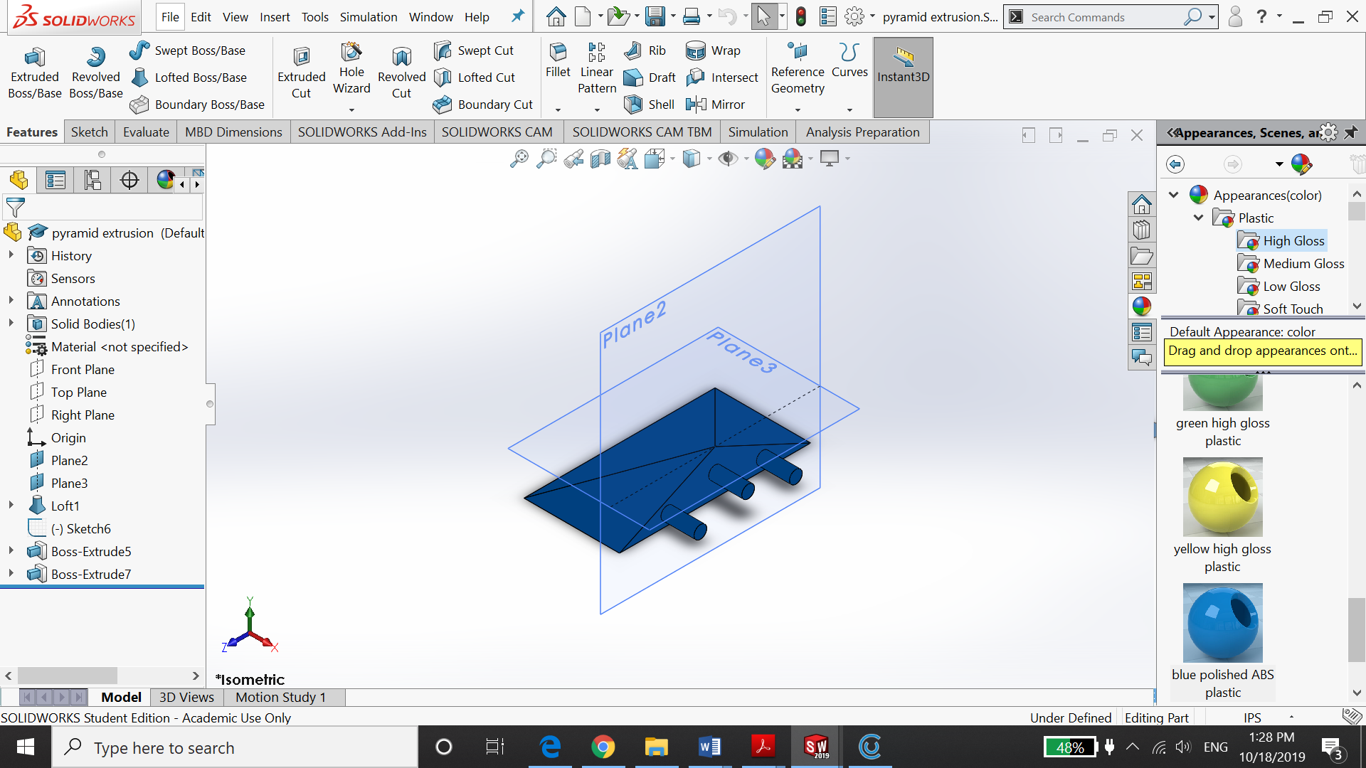

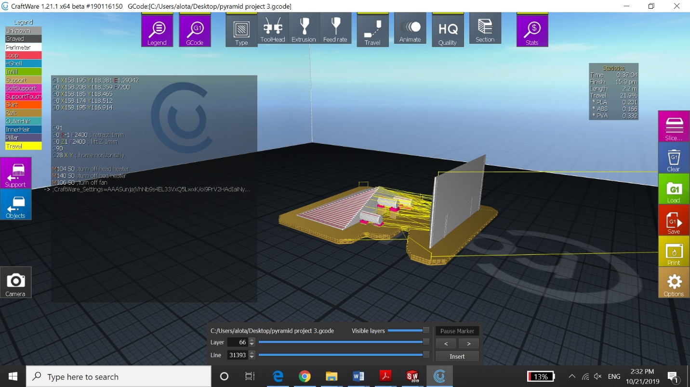Figure 8: Pyramid with Pegs-Solidworks

Figure 9: CraftWare 3D software, with raft and supports

Two Solidworks files were created, saved, as STL files and were inserted into CraftWare. Notice how the pyramid with holes is facing downwards.

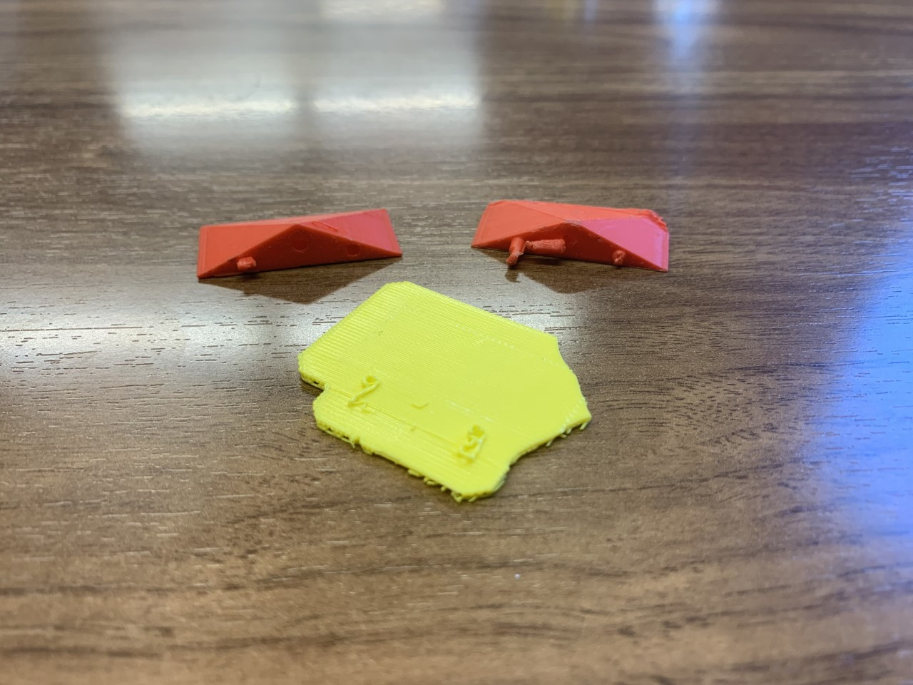

Figure 10: Failed Iteration and removed raft from second iteration

References:

1. “3D Printing Tips: How to Fix Warping: Ultimaker.” *Ultimaker.com*, ultimaker.com/en/resources/19537-how-to-fix-warping.
2. Giang, Ken. “PLA vs. ABS: What's the Difference?” *3D Hubs*, www.3dhubs.com/knowledge-base/pla-vs-abs-whats-difference/.